
- File
- Training Course
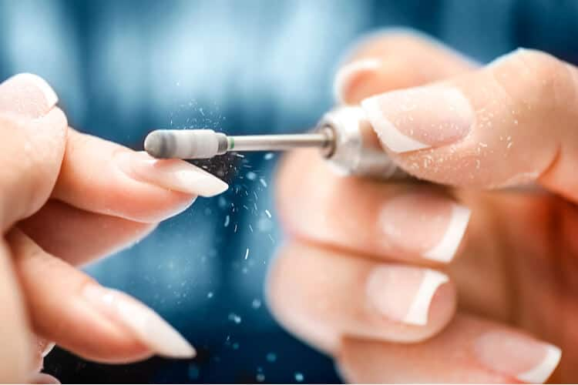

Aims & Objectives
The aim of this manual is to teach you the theory related to the safe use of an e-file, particularly the following:
- Anatomy of the drill
- Groom the cuticle
- Remove extension product
- To provide a relaxing treatment
This manual covers the background, benefits, treatments, consultations, contra-indications, contra-actions, aftercare, equipment and products needed.
You will be taught the theory and practical element of the course.
The objective of this course is that by the end of it you are able to perform a professional treatment in a safe and hygienic manner in a commercially acceptable time, along with gaining experience of carrying out a consultation with the knowledge of the background, benefits, contra-indications, contra-actions, aftercare, equipment and products needed.

Course details
During this course you will learn how to;
Prepare the treatment area
Carry out the treatment to a standard that meets client’s requirements
Provide after care advice
Provide safe removal of nail products

You will also study
Related hygiene, health and safety
Treatment procedures

You will study theory and practical elements required to perform a professional treatment

Once you have successfully completed, you will receive an accredited certificate
Good luck and enjoy!!

Introduction
Before using your e-file, you want to be sure that you have a thorough understanding of the way it works, you need to know how to operate it safely, to prevent any damage to yourself or your clients nails. After all, how many times have you heard horror stories of disasters and seen some toe curling clips on YouTube about accidents? We’ve all watched them with fascinated horror!
How safe are electric nail file machines and how to choose an electric nail file? Not every electric nail file you find is good quality. If you find a cheap one, the odds are it isn’t going to work very well.
So before you take the plunge, make sure you find the right model you can use easily and comfortably. After all, you want to feel comfortable using your e-file. You may even need to try a few different models before you settle on the one which really performs well to your standards.
Which e-file?
Choose an e-file with Low Vibrations
Most of the time, you’ll be using your e-file over an extended period of time, while you work on all of your clients nails. So you want to be sure that the drill bit will turn and not vibrate while you’re using it. Vibration can not only cause damage to your clients nails, but to the wrist of the arm you are holding the equipment in.

An important point in deciding how to choose an electric nail file that’s right for your needs, take into consideration the type of work you’ll be doing, and how often you’ll use it.

It’s worth choosing A better quality e-file. Yes, they cost a little more, and that extra cost will pay off in the long run with a quality, precision instrument that will last you for years to come. Cheap tools are not a good choice!
The best e-files can adapt to most standard file bit sizes, which is what you should look out for when making your purchase. That way, you know you can gain steady control of your nail filing area without having to accommodate to a size that’s too big or too small.
Overall, here are the top 4 factors you should look for when buying the right electric nail file:
Drill bits must accommodate standard file sizes.
Drill bits should not vibrate too much.
The drill should carry enough power to allow for extended use.
The drill should come with a warranty or at least with technical support.
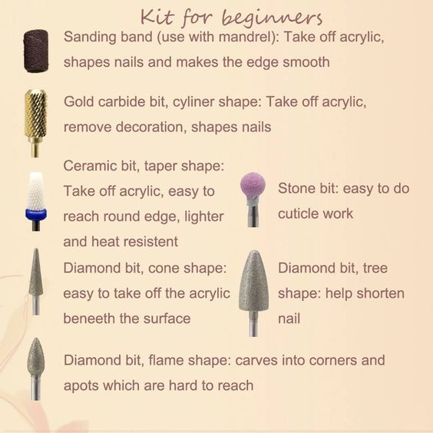

Hygiene, health & safety
Maintaining a high standard of hygiene as a therapist is essential. Not only from a health and safety perspective, but clients will not return if the salon, treatment area, or equipment are not clean. It is vital therefore to ensure that we provide a safe environment for clients.
The Health and Safety at Work Act 1974 places a duty on employers and the self-employed to protect the health and safety of themselves and others they employ, this also includes our clients.
A hazard is anything that can cause harm
Hazards therapist need to be aware of:
- RIDDOR (Reporting of Injuries Diseases & Dangerous Occurrences Regulations) 1995
- Moving & Handing of heavy loads or objects
- First aid training
- Ensure PPE (Personal Protective Clothing) is available and utilised where necessary using hazardous substances, materials or chemicals, especially those which can affect the skin.
For further information check out www.hse.gov.uk
Reporting Accidents and Incidents
The reporting of all accidents/incidents should be recorded in the accident book, which should be kept with a first aid kit on the premises.
The following information should be recorded:
- Full name and address of person(s) involved
- Circumstances of accident/incident
- Date & time of accident/incident
- Details of any contributing factors
Salon/Treatment area hygiene
- Clean the salon thoroughly daily
- Clean the treatment area before and after every client
- Use clean fresh towels for each client (dirty linen must be laundered at a minimum of 60°)
- Creams, lotions and sprays should be dispensed from purpose-specific pump or spray bottles where possible, otherwise use a clean disposable spatula to remove products from bottles/jars.
- Replace all lids after removing products from the bottles/jars.
- Sterilise all tools
- Empty bins and dispose of contents accordingly
- Check all plugs and wires on electrical equipment and make sure they conform to British Standards.
- Make sure all fire exits are clear and accessible
- Protect client’s clothing by using towels.
- Store products safely and in accordance with safety data sheets

There is a legal requirement to provide a safe environment for staff and clients who may be using your premises. Carrying out a risk assessment will identify any hazards, which is a situation that poses a level of threat or potential harm. If there is a hazard it is important to put controls in place to minimise the risk. Sensible measures need to be auctioned to reduce the hazard to provide a safe working practice.
It is important that risks are minimised and that all staff are trained in the event of an accident. There are some potential Salon hazards that will require a risk assessment, such as the Salon space, any chemicals being used, any equipment used and the security of clients and money.
Sterilising Equipment
Micro-organisms that may cause disease must be controlled through cleaning, sanitation, sterilisation or disinfection.
Sanitation
Reduces the number of pathogen bacteria. The lowest form of decontamination and is safe to use on the skin. This process removes dust, dirt and organic matter along with a large proportion of micro-organisms from an object.
Sanitation is essential before sterilisation or disinfection, the process is carried out by applying sanitising sprays, soaps or gels directly onto the skin, equipment or instruments.
Sterilisation
Kills all living organisms.
Several ways to sterilise the equipment:
- UV light
An enclosed steel cabinet that emits UV light when closed to kill off any bacteria
- Autoclave
Works by heating water under pressure to 100° which kills all germs.
- Barbicide (Chemical sterilisation) Liquid used to soak instruments, ammonia can be used as the liquid within the barbicide.
Disinfection
This greatly reduces pathogenic bacteria on work surfaces, this method is not suitable for skin, hair or nails. Disinfection is used on floors, work surfaces, workstations, walls, bowls.
How to clean and sanitise nail drill bits?
Proper sanitation of tools and bits is very important whether you’re working on yourself or on others. Good cleaning and sanitation will prevent you from getting or transferring infections such as fungus and more. You should never work with a dirty bit or tool. Remember to properly clean and disinfect your tools after every client.
There are several ways you can disinfect your bits and manicure pieces. Follow these steps and get your tools clean and ready for work.
First step: Cleaning
The cleaning part is super important because it reduces the number of germs significantly. Use a clean & small brush. Then, soak it in a bowl with warm water and soap. Scrub and clean your tools with the brush from every visible debris or dirt.
Another way to clean your metal nail tools is to put them in acetone for 7-10 minutes.
Second step: Disinfecting
The easiest way to disinfect your metal tools and nail drill bits will be to use a liquid disinfectant. Immerse your metal bits and tools only for the time that is recommended on the disinfectant label.
If you have rubber bits, you need to remove the used portion of the bit. Use your electric nail drill with a coarse bit and very carefully remove the used part of the rubber bit. After removing the outer used layer, immerse the rubber bit in an approved liquid disinfectant.

Drill Anatomy

Handpiece
Lock and chuck to tighten – 3 bars inside open and close, spins and tightens. Always tug to check.
Motor – Power cord safety, clear from dust and debris.
Dust – Always clean when bit enters and finished this can cause friction in the motor.
Control unit – Always turn off power before switching directions. Battery pack or cordless. Indicator lights for speed and battery life.
RPM
This is how fast the bit turns anything between 20,000-30,000 when on full max speed.
The torque is the ability on how the machine spins.
3,000-5,000 rpm for natural nail and cuticle area.

Treatment
Always make sure you give yourself plenty of time to prepare and set up your workspace before the client arrives.
- Begin by covering your workspace with a towel and some couch roll.
- Sanitise your client’s hands as well as your own, and then check the hands and nails for any contra-indications.

Nail drill bits
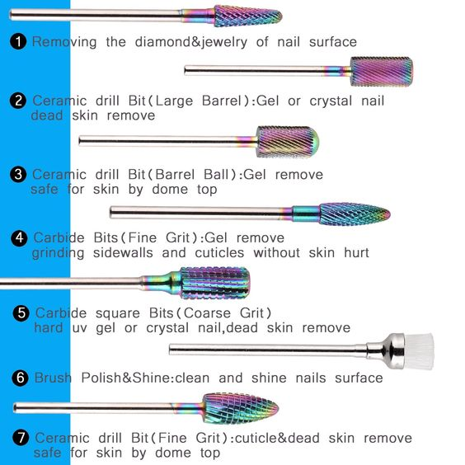
Sanding bands/mandrel
The Mandrel bit is typically made of metal or rubber. You can slip the mandrel top into the sanding band and you good to go. Sanding bands cannot be disinfected. That is one of the reasons why sanding bands are one-use-only paper bits, so you have to change a sanding band after every client. The sending bands are commonly used for surface work, removing gels, and pedicures. They come in various grits: coarse, medium and fine.
Gold/silver Carbide Bits
The carbide bits are made of carbide metal (which is 20 times stronger than steel). The carbide bits are meant to be long-lasting. They have flute-like cuts on the carbide bit. These cuts enable the carbide bit to shave the enhancement product off and not scratching it like the diamond bits. The grid scale is determent by the flutes on the bit. Dip and large flutes give you coarse grit. Shallower flutes commonly indicate a finer bit. Carbide bits are a great tool for advanced users and are ideal for removing acrylics. The carbide bits can be cleaned.
Ceramic bits
The great thing about ceramic coated bits is that they are long-lasting. The ceramic bit also has flute-like cuts, which help the bit to shave off the product. You can find the ceramic bits in several grids such as medium coarse and fine coarse. The ceramic bits is intended to reduce heat. Ceramic bits can also be cleaned and sterilized.
Diamond Bits
Diamond bits are typically made of synthetic or natural diamond partials. They are strong and long-lasting. Diamond bits come in a variety of grids from fine to extra coarse. Diamond bits, unlike ceramic and carbide bits, scratch the material off the nails instead of shave it off. Sometimes, this can be a disadvantage. Low cost diamond bits may remove the product unevenly (you don’t, however, have this problem with higher priced diamond bits, which are often higher quality). Diamond bits can be cleaned, too
Natural Nail Bit
This kind of nail bit is commonly made from synthetic rubber. The natural nail bit is used to buff the surface of the nail, remove dead cuticle on the nail, and smoothen the cuticle area. Synthetic rubber bits wear down fast, so remember to reshape it with a simple hand file after every use.
Large and Small Barrel bit
The barrel bits are great for doing surface work on the nail. You can also use the barrel bits for infill cutting, shortening, and shaping the nail, and to make a smile line.
Tip: Make sure you don’t use this bit in the cuticle area! You may cause some damage to the nail (rings of fire).
UNC Bit
The UNC bit is an under the nail cleaning bit. The shape of the UNC bit is pointed and small. The point size changes from manufacturer to manufacturer. This particular shape helps the bit to get in tight spaces. The UNC bit is commonly used not only for under the nail cleaning, but also for sidewalls. Some nail technicians also use this bit for making designer holes in the nails.
Cone Bit
The cone bit has a long, slim and tapered shape. You can use this cone-shaped bit for several purposes, such as preparing the cuticle area and sidewalls, and cleaning under the nail. You also can use the cone bit on the top of the nail. It is a great shape for toenail surface work, but not the best shape for fingernails surface work.
Tapered Barrel
The Tapered barrel bit has a flat top and a cone shape to it. It is shorter than the cone bit and is great for surface work, in-fill preparation, cuticle, and sidewalls preparation.

Safety Bits
These are actually cuticle safety bits and are designed for safe cuticle work. They are rounded at the top and come in a great variety of shapes. With these bits, you can easily reach the cuticle and sidewalls without damaging the nail. They are great for in-fill cuticle work.
Mandrel Bit
This bit is commonly made of rubber or metal. You can work with the mandrel bit only after slipping it into the sanding band. The sanding band is made of paper and needs to be replaced after you work on a client.
Maintenance bits/infill bits
The maintenance bits or the infill bits are great for replacing the white tip powder on a French manicure and correcting and redoing the smile line. There are several types and sizes of maintenance bits.
The 2-week bit is used exactly for what it sounds. It trenches infill after two weeks of growth. The size of this bit is a quarter of a large barrel bit.
The 4-week bit is used to trench infill after four weeks of growth and is half the size of a large barrel bit.
Some helpful safety techniques in how to use an electric nail drill safely
Here are a few helpful techniques in how to use a nail drill that can really teach you how to use an e-file safely and how to master your e-file drill basics.
Use a slow speed for the cuticle 3,000-5,000rpm - The cuticles are extremely thin and sensitive, and the slightest tear or rip can send your clients in to a world of pain. Plus, it opens your clients nail up to the possibility of infection. Use an extremely slow speed when working in this vital area.
Use a medium speed for backfills 5,000-9,000rpm - When you are filing the backfill or concave area of the nail, you can speed things up just a little bit. However, don’t go too fast, or you can risk damaging this portion of the nail as well.
Use a fast speed on the nail surface 20,000-30,000rpm - When filing the surface of the nail itself, you can move the speed up to 30,000 RPM while shaping your nail. However, be sure to never ever go any faster than this!
You don’t want to be too gentle, nor too harsh on your client’s nails. Find a perfect combination of gentle pressure that will help you to successfully shape your clients nails while you grow accustomed to how the e-file works.
As long as you get the hang of handling your drill safely, and with varying speeds, you can easily work on a natural nail. There are a wide variety of bits and bands to use and experimenting on how to use these e-file bits gives you valuable experience on how they work and what results are produced.

Drill Directions

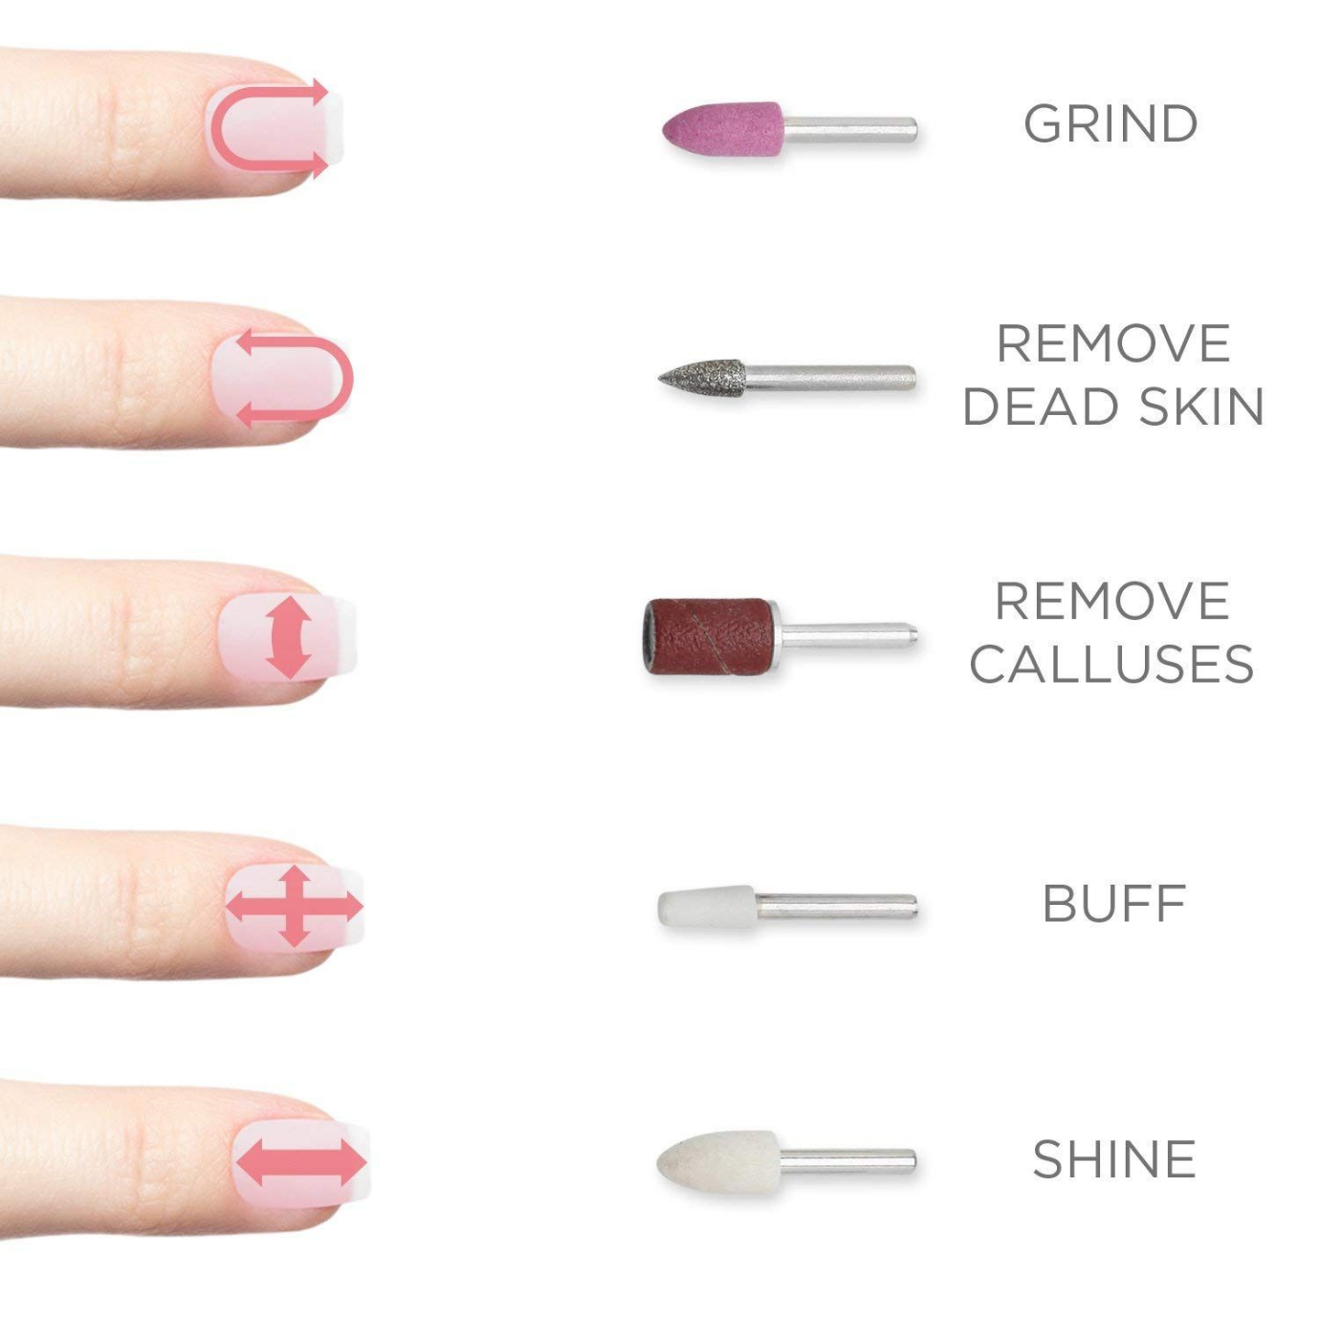
Try using an extra fine diamond band or a silicone sanding band with natural nails. This is the best way to shape and buffer your client’s natural nails.
- The first step you’ll want to take is to slowly and carefully push the cuticle back. It’s essential to get rid of dead skin before moving on to the rest of the nail. While working on your client’s natural nail, keep your e-file at a speed between 3,000 and 5,000 RPM. Anything faster might risk damaging or cracking the surface of your client’s natural nail. Keep the bit flat to the nail while you are working.
- Hold your drill in a horizontal position while you file. This is the best way to gain the best control over your workspace, which in this case is your clients nail. Move the drill from one side of the nail to another, in slow circular motions to remove dead skin and file them down.
- Medium barrel or diamond drill bit is the perfect solution for finishing a nail. After you’ve cut and shortened it, you can tightly drill it with gentle side-to-side motions for a finishing touch. Be sure to use a medium speed.
- For infill, you can use a straight barrel or specialized infill bit for the same process. Infills require a faster speed, since they are often thicker than natural nails.
- Preparing for a full set, you can use a diamond or coarse silicone bit while pushing back the cuticles and pressing the bit flat against your client’s nail. Use a slow speed, such as 3,000 RPM, to apply minimal pressure to all parts of the nails.

Shank size
The standard nail drill shank size is 3/32.″ Remember that the shank size of electric files that are for craft use are usually 1/8″ and they will not fit a professional electric file.
Grits
You can measure the grit of your nail drill bit by the number of abrasive partials per square inch. The more partials you have, the smaller they are.
In coarse bits, for example, you will see large partials on the bit and the number of grits will be lower.
As a general rule, you want to use slow speed for the cuticle, medium for backfills and concave shapes and a fast speed for the shaping of the surface of the nail. If you exceed the 15,000 RPM, you can severely damage the nail.
If you want to know how hot the nails of your clients are, you simply have to place your thumb on the hand that is working on the nail of your customer. Heat builds up faster on the upper part of the nail, so you will be able to lift the bit before they start feeling pain.
Always grab your customer´s hand steadily in order to avoid unwanted vibrations. Chances are you will need to place your pinkie or ring finger against your hand for a better balance and precision while working.
Remember you should not apply too much pressure, nor should you be too gentle on the nail.

Removing Lifted Acrylic – 10,000-15,000rpm
The amount of complaints caused by lifted acrylic is immense, which is why removing it with electric nail files is strongly recommended. In case you didn't know how to do it, here´s a quick guide on it:

Type of bit used: Tapered
1. make the part of the product that is closer to the cuticle slimmer.

2. Use solely side-to-side movements while keeping the bit flat at all times. Only when the product has been removed should you use a one-stroke movement along the sealed and loose acrylic to remove what could remain of acrylic.

3. You should not worry if an irregular white shadow appears around the product, for it won't be displayed under the acrylic. Just continue like you normally would.

Repairing a Crack – 3,000-5,000rpm
It's not odd to see a crack on acrylic nails. However, you can easily remove them using an electric nail file.

Type of bit used: Mini French-filled diamond
1. Before you prep the nail, start working on the crack. Because the nail is still even and shiny, it will be very easy for you to notice the crack.

2. The next thing you have to do is drill out the crack using a low speed that ranges between 3,00 and 5,000 rpm. Bear in mind that going to slowly could create vibrations, causing air pockets to appear on the nail.

3. Now for the final step, you have to hold the bit in a parallel position to the nail. After that, apply a constant pressure that starts from the outer part of the nail and goes to the crack. Take into consideration that you should only remove enough material to finish the repair and continue.

Prepping for a Full Set – 2,000 rpm
As a nail technician, you should know that prepping the nail is one of the most important steps when it comes to artificial nail application, for it will make them last way longer and will prevent them from lifting.

Type of bit used: Fine sanding band/ medium-fine diamond/coarse silicone.
1. Push back the cuticles in order to keep the bits from grabbing and hurting the skin of the patient.

2. Now you have to press the bit flat against the nail while using a speed of 2000 RPM. Make sure you are making minimal pressure and you´ve gone over every single part of the nail. Lift the bit from time to time in order to avoid the heat to build up and damage the nail.

3. Get closer to the cuticle to remove any dead skin without angling the bit.

4. It´s important that you move your client’s hand according to your needs instead of trying to manipulate the machine around their hand.

Working on the Natural Nail
If you do it using the right tools and with the correct knowledge, using an electric file on a natural nail is just as safe as using any other kind of file.

Type of bit to use: Extra-fine diamond /extra-fine sanding band/ silicone

1. Just like you normally would, slowly push the cuticle back while exposing any dead skin. It´s very important that you use a drill-friendly oil when you´re using the bit, for it makes the contact between the bit and the skin flow nicer and smoother. Using the bit, remove ridges and smoothen the nail´s surface.

Because you´re working on a natural nail, you want to use a slow speed that ranges from 2,000 to 5,000 RPM. Remember that you have to keep the bit flat to the nail and hold it in a horizontal position at all times. Now all you have to do is move it from one side to the other while remove the dead skin by moving it in a circle motion with the bit.

2. Next, use an extra-fine sanding band along with the drilling oil. Hold the bit horizontally going from one lateral fold to the other. Come up on the cuticle, keeping the bit flat.

3.Now that you´re almost done with the process, you want to combine a cotton buffer with a buffing cream in order to provide the nail with a shiny look by using circular movements on the surface. Now all you have to do is massage the nail with cuticle oil, which will make it stay shiny and smooth until it grows back.

Backfills – 5,000-9,000 rpm
Just like every other process, using an electric file for backfills will enable you to finish the process way faster and it will make it drastically easier.

Type of bit used: French-filled diamond/carbide straight barrel/specialized backfill
1. The trick for this process is to make use of the inside part of a nail form and a pencil in order to draw a curved line, similar to a smile. Of course, this trick should be used for beginners as a guide so that they know where they should drill.

2. This time you want to use a slightly faster speed, more precisely one ranging between 5,000 and 9,000 RPM. Now you want to position your hand at an angle of 10 degrees (approximately) to cut a new curved line on the nail. Using a speed between 5,000-9,000 RPM, position the hand at a 10° angle and cut a new smile line. You have to remember that the white acrylic darkens with time and, on the contrary, the white tip is way lighter and will remain as a whiter line if you do not remove the entire tip when you are performing the backfill. We recommend you retire an average of 80% of pink and 60% of white.

3. Bear in mind that you don´t necessarily have to use a diamond barrel bit, for you can also opt for a carbide straight barrel bit. If this is your case, just make sure you start working on the right part of the nail and continue towards the left side. Also, remember you should hold the bit in a parallel position and should not apply too much pressure.

Finishing a Nail 5,000-10,000 rpm
As you´d expect, an electric file is your absolute best friend if you want to achieve a soft and shiny look.

Type of bit used: medium barrel/diamond/carbide/extra-fine diamond
1. Again, unexperienced technicians can use a pencil to draw on the nail in order to use these drawing as a guidance.

2. After the nail has been shortened, support is by holding it tightly in order to avoid vibrations. Apply pressure all over the nail and use side-to-side movements when you are shaping the nail. When you do this, the bit should float across the nail of your customers. The speed of your bit should go between 5,000 and 10,000 RPM.

3. Always remember to keep the bit in a parallel position and move the customer´s hand to make the process easier. Lower the speed to RPM when approaching the cuticle.

4. Now all you have to do is smoothen the nail with your extra fine diamond bit and use the drill friendly oil.

Self-Assessment
Do I have a good understanding of-
- The different drill bits
- Hygiene, health and safety
- Sterilisation
- Required items and supplies
Can I:
- Set up my area
- Complete a thorough consultation
- Perform a full treatment

Well done!!!

Notes

